SOFT10101 Computer Science Programming
Coursework 2025/26
Nottingham SkyRoute Explorer
Name: Spoorthy Tankari

Specification
This project is an airport search engine. The program loads a global dataset of 82,808 airports from a CSV file called airports.csv into memory at startup.
The program runs in the console and does not use any additional libraries.
Key Features:
- Search airports by country code
- Search airports by partial name
- Search airports by IATA code
- Count airports by type
- Add a new airport
- Save changes back to CSV
- Advanced options including Haversine distance calculation, nearest airport to coordinates, airports within radius, highest and lowest elevation, missing IATA detection, and sorting by multiple fields

Design and Implementation
Program Flow
The program starts in main.cpp. A DataManager object is created and loads the CSV file into a vector of Airport structs. A SearchEngine and AnalysisEngine are then created, both taking a reference to the same airports vector owned by DataManager. A UI object is created taking references to all three components and runs the main menu loop. When the user exits, DataManager saves all airports back to the CSV file.
Classes
This project contains five classes/structs as follows:
Airport — a plain data struct holding all 13 fields from the CSV: ident, type, name, elevation_ft, continent, iso_country, iso_region, municipality, icao_code, iata_code, gps_code, local_code, and coordinates.
DataManager — responsible for loading and saving the CSV file. Owns the vector of Airport structs. Uses ifstream to read line by line and stringstream to split fields. Handles the coordinates field which contains a comma inside it by reading the first 12 fields then taking the remainder of the line.
SearchEngine — takes a reference to the airports vector and provides search methods. Implements case-insensitive searching using std::transform and std::string::find.
AnalysisEngine — takes a reference to the airports vector and provides geographic calculations using the Haversine formula, elevation analysis using std::max_element and std::min_element, sorting using std::sort with lambda functions, and grouping using std::map.
UI — takes references to all three components and runs the menu loop using a do-while loop and switch statement. Handles all user input validation using cin.clear() and cin.ignore().

File Structure
The file structure for storing airport data is a CSV file with each airport on a separate line with 13 fields:
ident, type, name, elevation_ft, continent, iso_country, iso_region, municipality, icao_code, iata_code, gps_code, local_code, coordinates
For example:
EGLL, large_airport, London Heathrow Airport, 83, EU, GB, GB-ENG, London, EGLL, LHR, EGLL, , 51.4775, -0.461389

Test Plan
The following is a test plan for the project:
Action | Test Method | Success Criteria
Load CSV file | Run program | 82808 airports loaded message appears
Search by country | Enter option 1, type GB | List of UK airports displayed
Search by invalid country | Enter option 1, type XX | Found 0 airports message
Search by partial name | Enter option 2, type logan | 23 airports containing logan displayed
Search by IATA code | Enter option 3, type LHR | Full details of Heathrow displayed
Search by invalid IATA | Enter option 3, type ZZZ | No airport found message
Count by type | Enter option 4 | Table showing counts for each type
Add new airport | Enter option 5, fill all fields | Airport added successfully message
Search for added airport | Enter option 2, search by name | Newly added airport appears in results
Save changes | Enter option 6 | Saved changes confirmation message
Nearest airport | Option 7 → 1, enter lat 51.5 lon -0.1 | Returns nearest airport to London
Airports within radius | Option 7 → 2, enter 50km radius | Lists all airports within 50km
Highest elevation | Option 7 → 3 | Shows airport with highest elevation
Sort by name | Option 7 → 6, field name, ascending | Airports listed alphabetically
Invalid menu input | Enter letter instead of number | Invalid option message, no crash

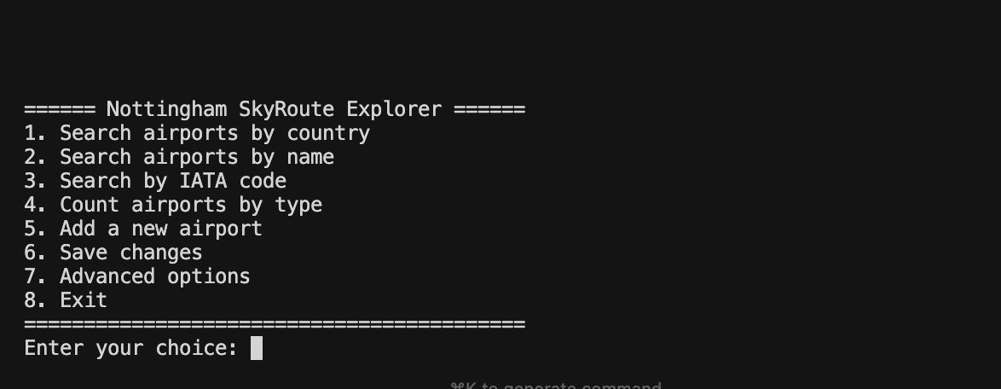
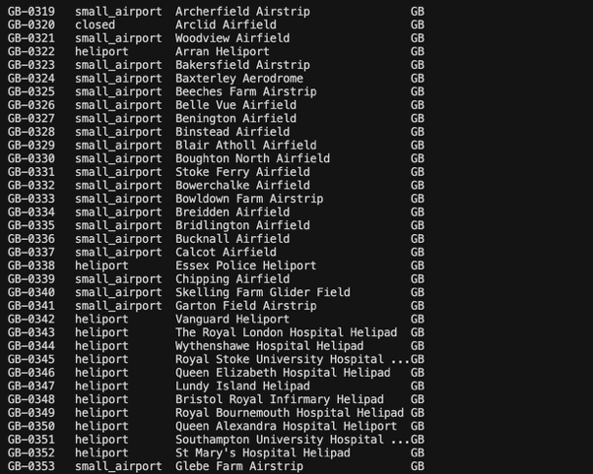

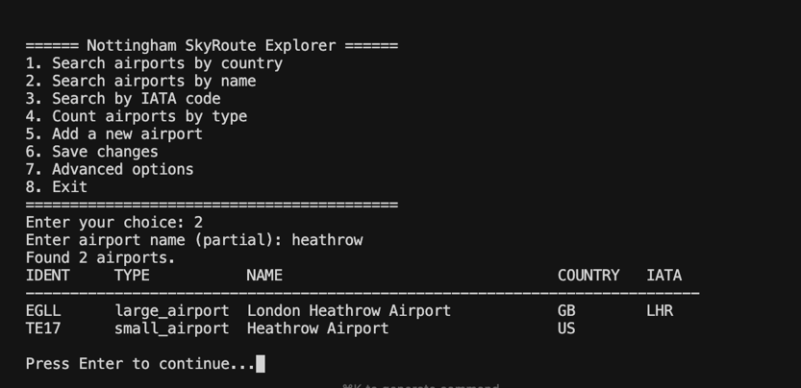
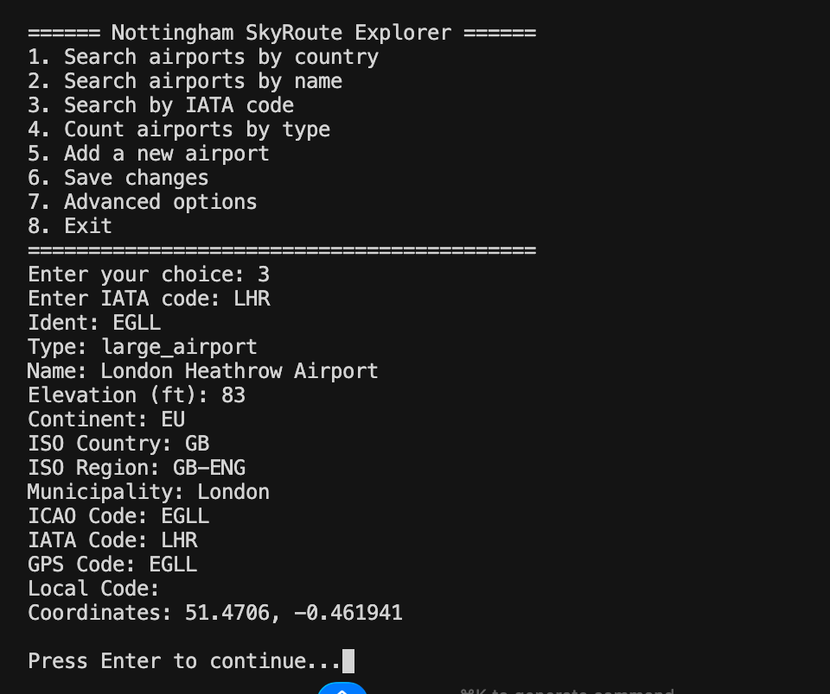
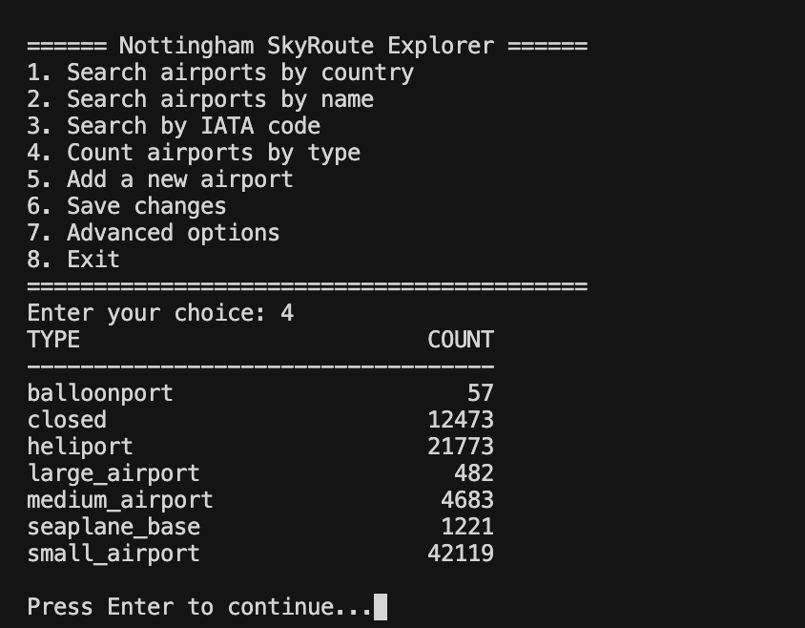
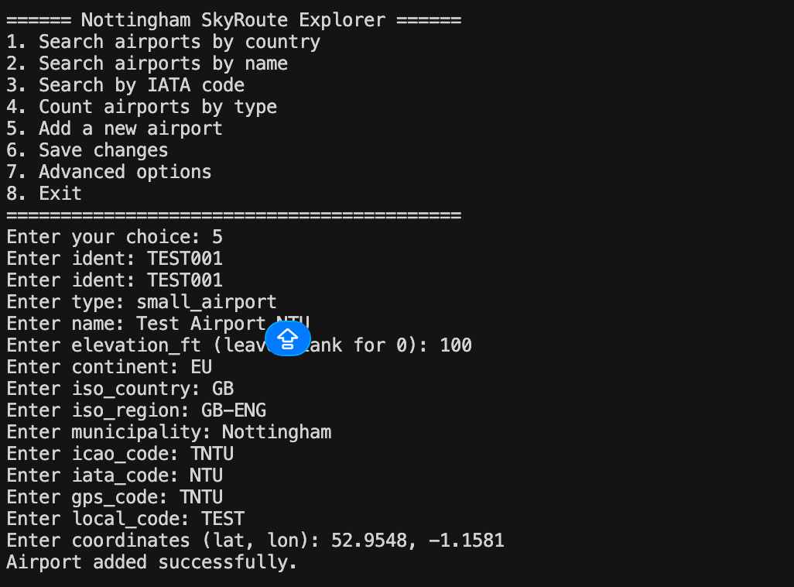

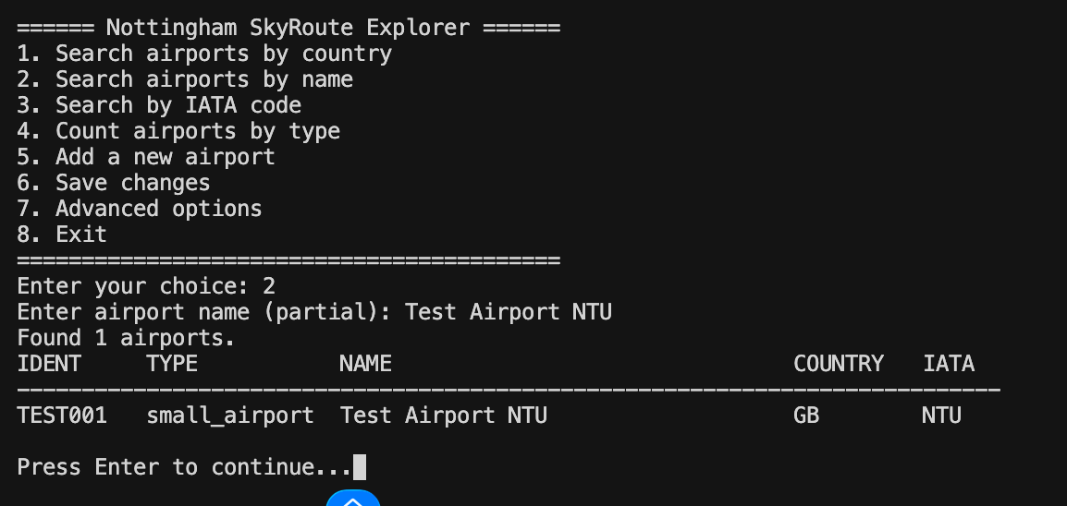
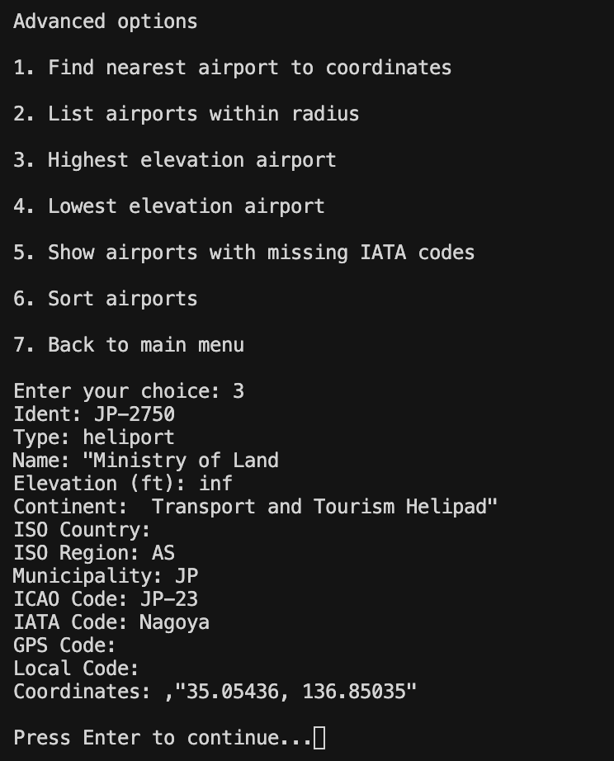
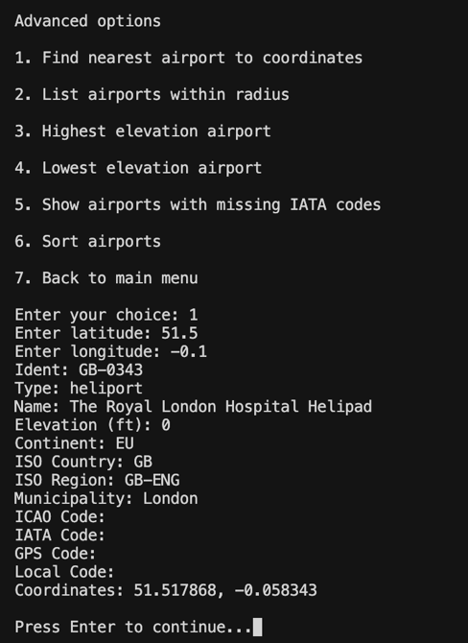

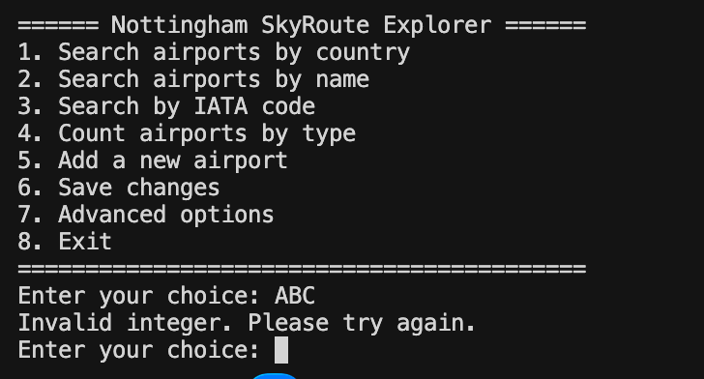

Demo
A 5-10 minute video demonstration of the program is provided showing all menu options working including CSV loading, search by country, name and IATA code, adding a new airport, saving changes, and all advanced features including nearest airport calculation and elevation analysis.

